Installing Visual Studio Code for MacOS

The code in this course is written in **Visual Studio Code** (also known as VSCode). VSCode is a free, open-source text editor funded by Microsoft. It is available for all major operating systems.

* Navigate to [**https://code.visualstudio.com/**](https://code.visualstudio.com/)and the click the green **Download** button. The browser should automatically determine your operating system.

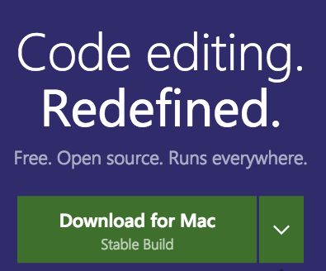

* Unzip the **.zip** fileto reveal a Visual Studio Code application. Drag it your **Applications** folder.
* Open the Visual Studio Code application.
* On the left side, you'll see a toolbar / menu. Click the last icon (Extensions).
* Search for "Ruby" in the search bar and find the **Ruby** extension by Peng Lv. This Gem adds syntax support for the Ruby programming language.
* Click the green **Install** button either in the list of options or the description pane.

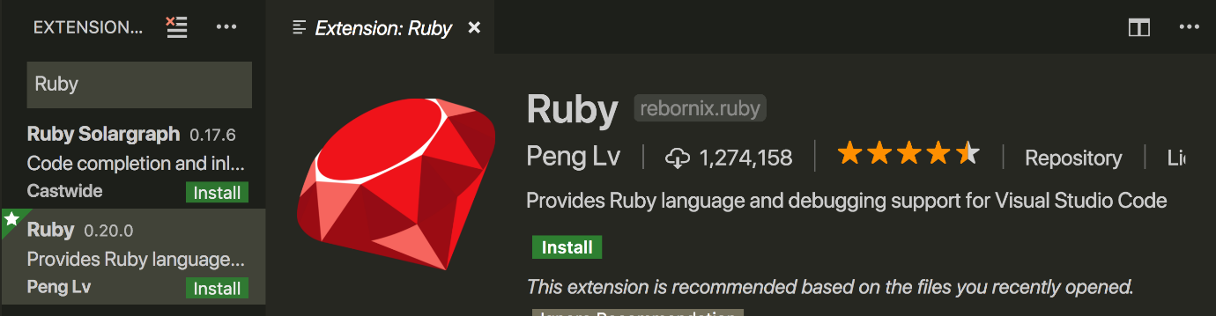

* Click the **Reload to Activate**button to load the extension. This is a one-time operation.
* Press **Command + Shift + P**to open the Command Palette. Search for "Shell Command: Install 'code' command in PATH" and click it. This will setup VSCode to work in the Terminal. The application can be opened with the **code** command.
* In the top menu of VSCode, click **Terminal > New Terminal**. We'll be using this in-editor Terminal throughout the course to avoid switching windows.

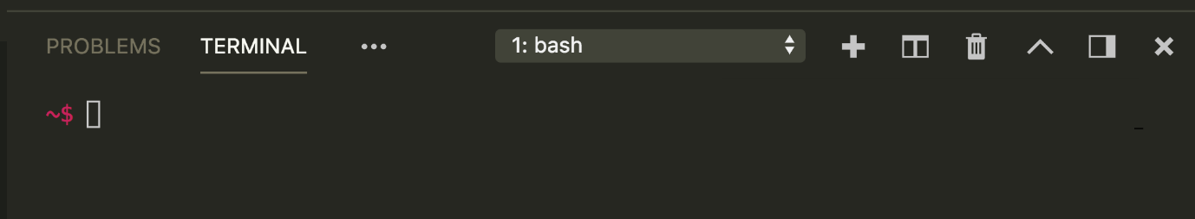

Resources for this lecture

* Website for the Visual Studio Code text editor - https://code.visualstudio.com/